**Release Notes**

Required Software:

* Eclipse Helios. (Used Version: SR2-win 32)
  + http://www.eclipse.org/downloads/download.php?file=/technology/epp/downloads/release/helios/SR2/eclipse-java-helios-SR2-win32.zip
* Android ADT. (Used Version: 18.0)
  + http://developer.android.com/sdk/installing/installing-adt.html#Configure
* Android SDK. (Used Version: 18.0)
  + <http://developer.android.com/sdk/download.html?v=archives/android-sdk-windows-1.5_r3.zip>

Installing ADT & SDK

* Launch Eclipse.

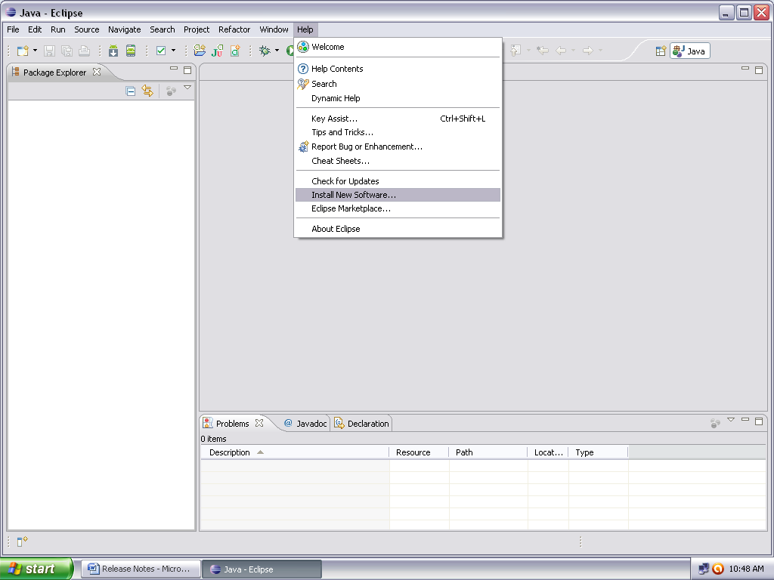

Click on Help->Install new software

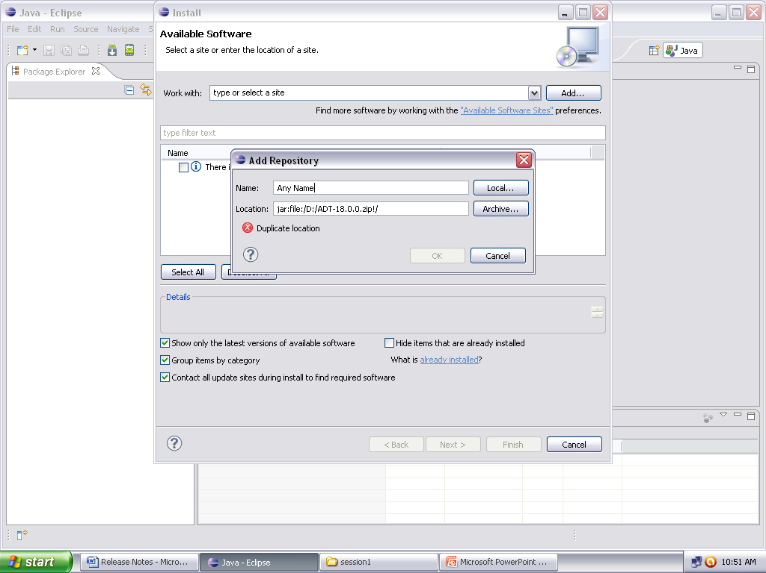

Give any local name & give the path of the ADT .zip file or the link from where to download.

Click on Add

* Select All next->...->Accept license -> finish.
* Restart Eclipse.
* Enter the SDK Path:

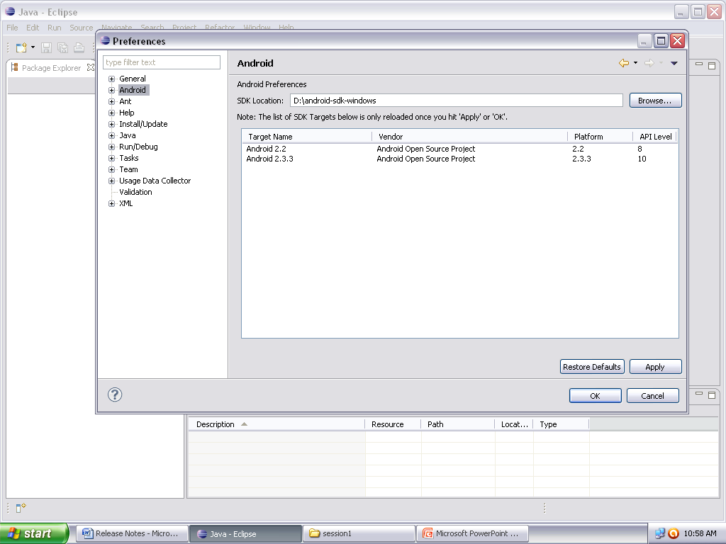

Available Versions.

Click OK

Browse the SDK folder click Apply

* Creating an Emulator:

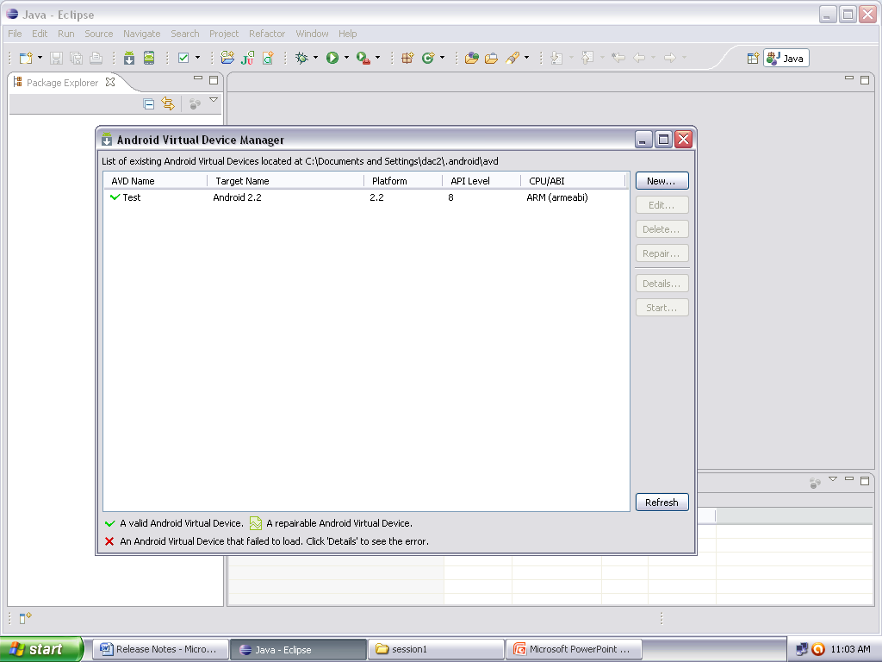

To create a new Emulator

Click Here to open Android Virtual Device Manager

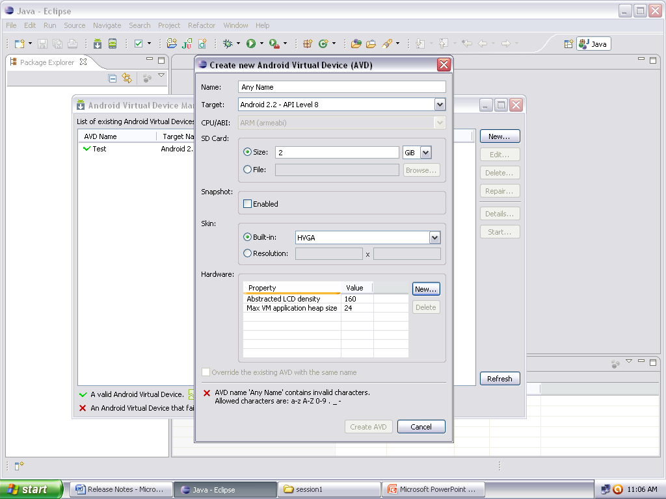

Create AVD

Any hardware support if needed.(in our case no need)

Screen Properties

SD card Size

Target Version

Emulator Name

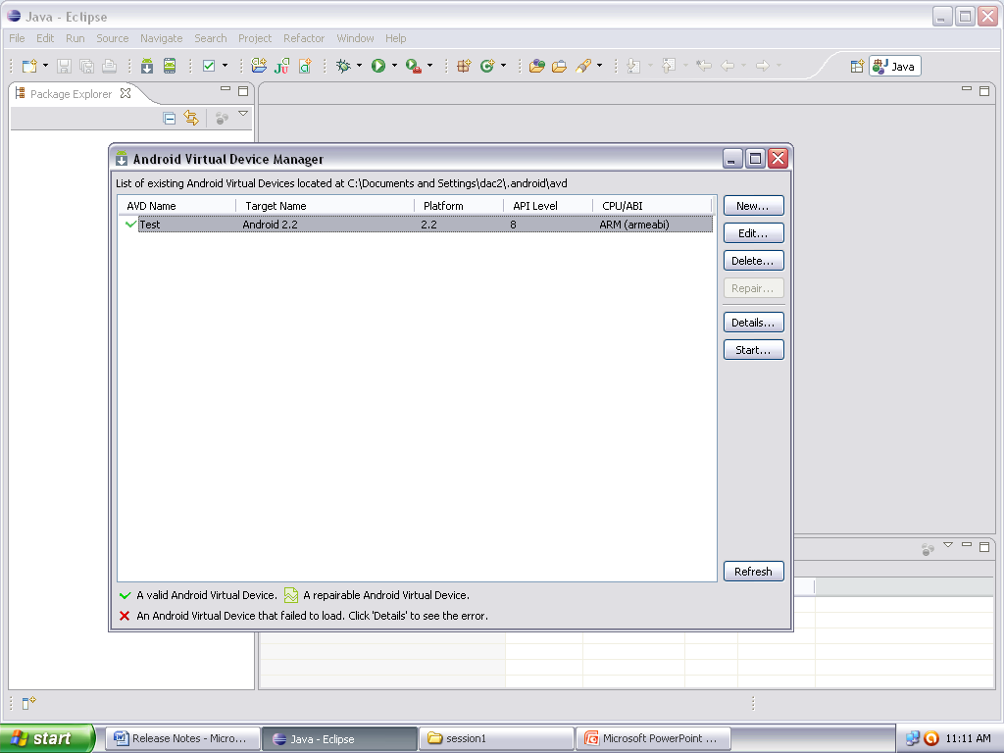

Select the Emulator and start.

* The Emulator has now started.

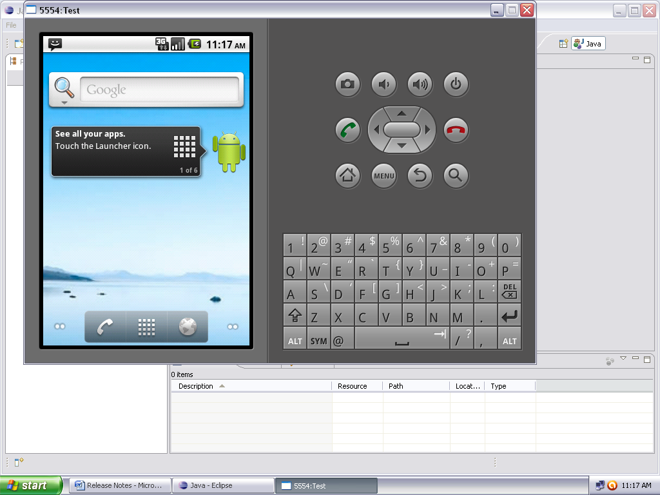

* Importing the project:

Eclipse->File -> Import -> General -> Existing Project Into Workspace -> Next -> Select the root directory of the Project -> ok.

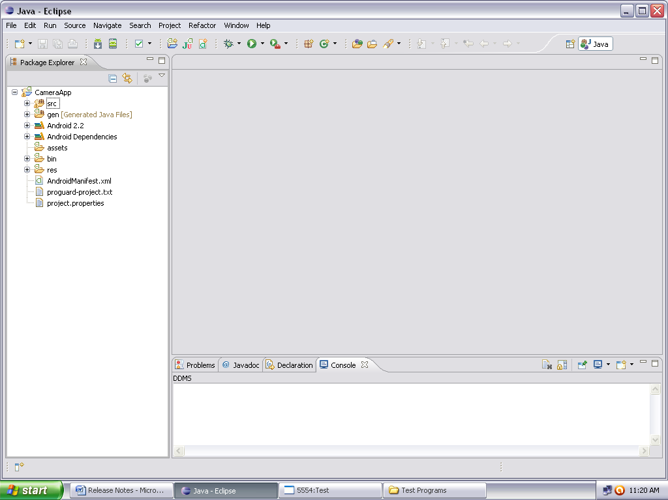

* The project source code is now available for further use.
* Installing The APK file onto the Mobile:
  + Copy the APK file onto the Mobile.
  + Click on the apk file to install & open.

(Note: The apk file is created in the bin folder or the project, when you run the project. Also make sure (for lower android versions) the Setting Allow applications other than market applications to be installed is checked. This option is available in the Settings->Applications section of the Android phone.[Settings->Application Settings-> Unknown Sources])

Home Activity:

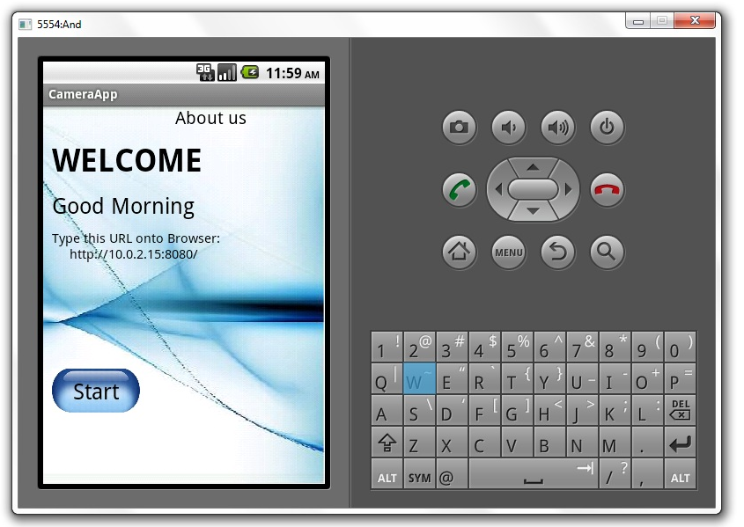

Type this address onto your browser so as to view the frames

Click Here to start Streaming frames

Click Here to View Details about the team

Note: The URL will be active only when the streaming starts. i.e. on clicking on the start button.

About Us Activity:

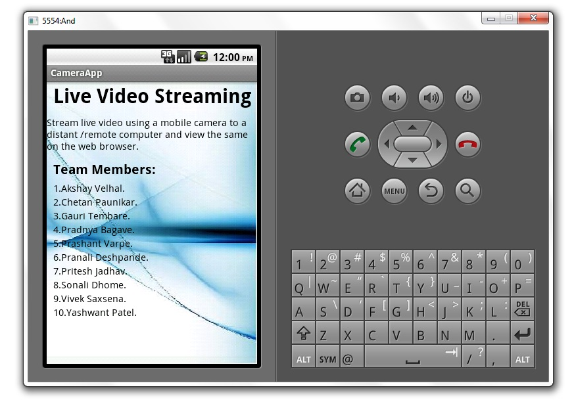

Sample Output:

